

Tool Hound Mobile App Access

- Contact Joe Taylor via email or text. The information needed will be your name and a password to log into the Tool Hound Mobile App.
- Joe Taylor- (330) 715-7842
- Joetaylor@thinkwelty.com

- Go To the app store- Tool Hound 6
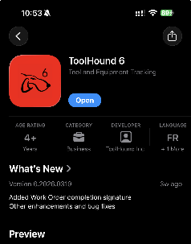

- Once App Is downloaded and your username/password is created by Joe. The next step is to open the app. It will open to a log in screen.
- Company name is- Welty
- Your username/ password
- Log in

Renting A tool On Tool Hound

- Here is a short video of how to create a requisition. When you are creating a requisition, you will use your job name as the Requested by line.
https://www.google.com/search?q=renting+a+tool+on+tool+hound+6+from+mobile+app&rlz=1C1GCEU_enUS1094US1094&oq=renting+a+tool+on+tool+hound+6+from+mobile+app&gs_lcrp=EgZjaHJvbWUyBggAEEUYOTIHCAEQIRigATIHCAIQIRigATIHCAMQIRigATIHCAQQIRigATIHCAUQIRigATIHCAYQIRiPAtIBCDcxNThqMGo3qAIAsAIA&sourceid=chrome&ie=UTF-8#fpstate=ive&vld=cid:5d414fa7,vid:YdiS1vMXMQI,st:0
Steps to requesting a tool

- Requested by- Job Name
- Date needed
- Return date
- Click on Cart
- Click the Search button top right corner
- Find tool in the inventory list.
- Click on part number to add to the cart, click on search again to continue adding parts to your list.
- When all tools are in the cart, click SAVE
- Once requisition is saved, the cart will get sent to Joe Taylor at the warehouse and he will pull all tools and get it on the delivery list for the dates needed.
-Each Requisition will be one order, one delivery date.

